NMRS META DATA AND NDR PLUGIN 1.6.2 OMOD DEPLOYMENT PROTOCOL

HEALTH INFORMATICS UNIT IHVN

4TH FEB. 2021

OBJECTIVE

The objective of this document is to provide a standard set of guidance on how to deploy the NMRS NDR 1.6.2 plugin module (nigeriaemr-1.6.2.omod) and the NMRS Metadata module (nmrsmetadata-1.0.0.omod). It also gives a detailed description of the problems that could arise and prescribes solutions to them.

BACKGROUND

NMRS EMR platform is a modular web application. NMRS allows developers to extend its functionality using modules. Modules are compiled into files ending with “.omod” and these files can be uploaded (deployed) into the NMRS.

NMRS NDR 1.6.2 Plugin (nigeriaemr-1.6.2.omod)

This module is responsible for generating NDR XML files to be uploaded to the NDR platform. The 1.6.2 version comes with the following improved features.

* It generates XML files that are compliant to NDR schema version 1.6 (NDR 1.6.xsd). The <MessageHeader> tag includes <MessageSchemaVersion>1.6</MessageSchemaVersion>
* Now Include PMTCT tags i.e. AntenatalRegistration, ChildBirthDetails, ChildFollowup, HealthFacilityVisits, PartnerDetails, InfantRapidTest, MaternalCohort and PMTCTHTS.
* Pick the right fingerprint template from the “new_template” blob column.

NMRS Metadata Module (nmrsmetadata-1.0.0.omod)

This module imports CDC approved forms and reports into the NMRS instance.

DOWNLOADING MODULES

New release of each NMRS module are kept on HITT github with link below;

<https://github.com/nmrs-nigeria/files_and_resources/tree/master/Release/1.6.2>

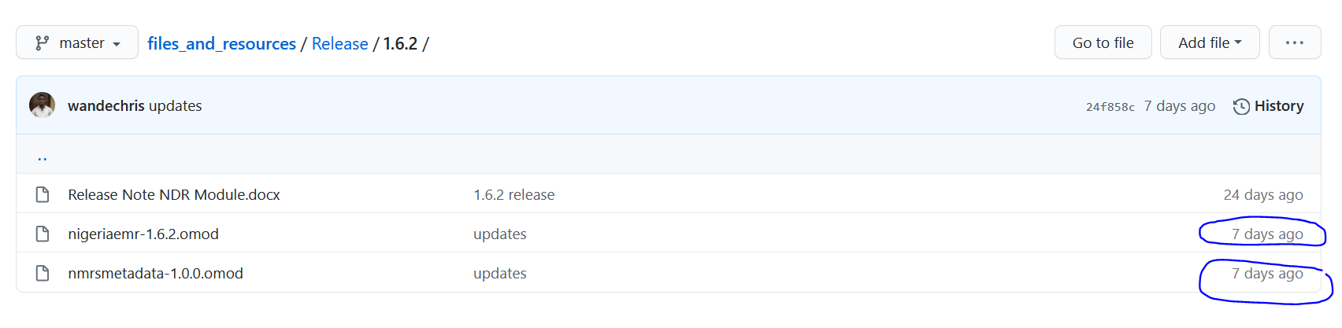

Please take note of the change timestamp on github repository and ensure that the module you deployed is the latest on.

HOW TO DEPLOY A MODULE

STEP 1 (DATABASE BACKUP)

Backup your database to sql dump file. This step is very important as a lot of things can go wrong during an omod deployment that might lead to serious data loss.

NOTE

Do not use the NMRS backup module to back up your database. Perform a data dump of the entire database using either navicat or workbench. Also feel free to use command line or a shell script utility that calls mysqldump tool.

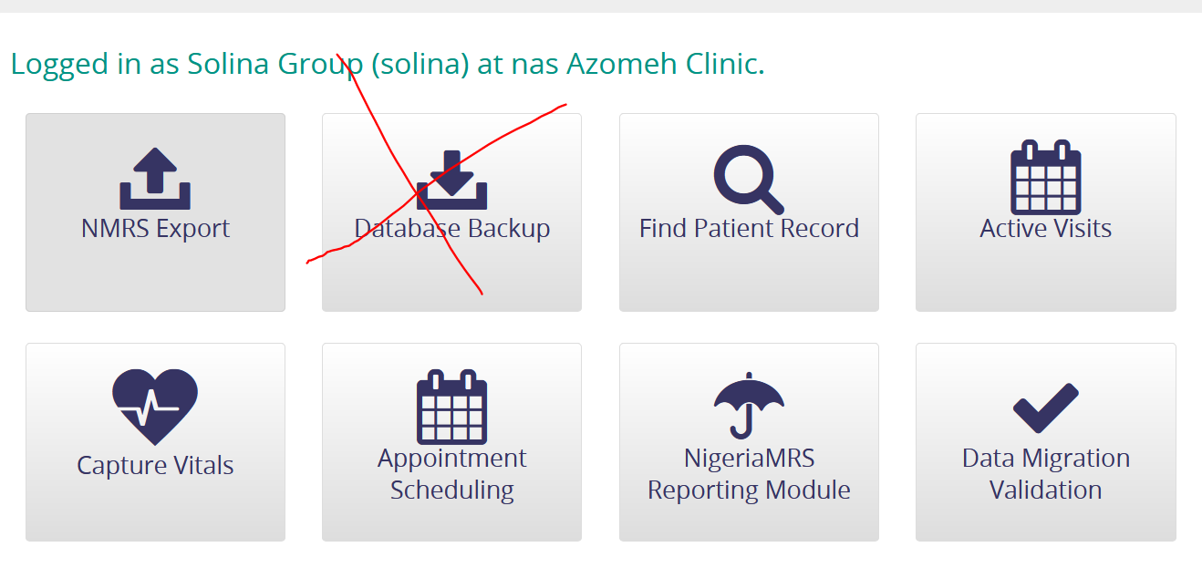

Link to recommended backup tool

<https://github.com/ihvn2020/ENTERPRISE-NMRS-2.0-SET-UP-SOP-USING-TOMCAT-9-BY-IHVN-HEALTH-INFORMATICS./blob/master/Startbackup.sh>

STEP 2 (STOP TOMCAT)

Tomcat service reads information from the NMRS “module” directory and it is recommended for you to tamper with the “module” directory while tomcat service is running.

STEP 3 (COPY OMOD TO MODULE FOLDER)

Copy the 2 omod files into the NMRS “module” folder of your installation.

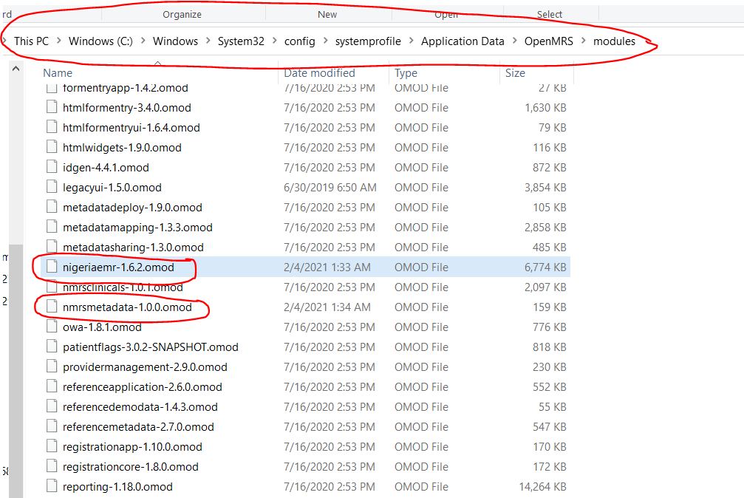

STEP 4 (RESTART TOMCAT)

Restart the tomcat service and login to the NMRS

STEP 5 (CONFIRM THE OMODS ARE RUNNING)

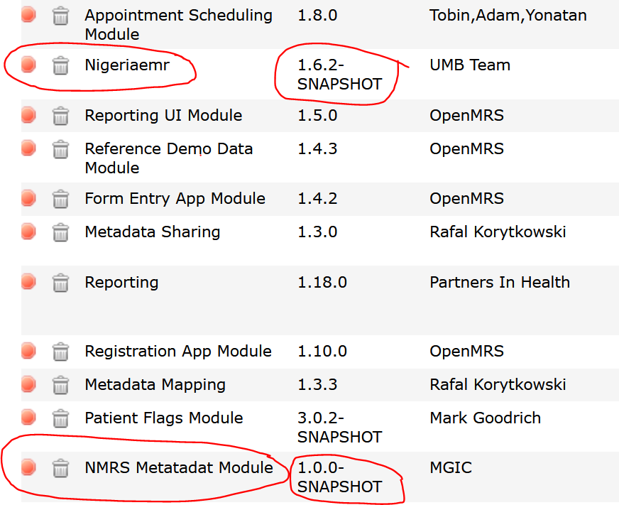

POST INSTALLATION STEPS

CONFIRM THAT THE NDR GENERATION IS WORKING

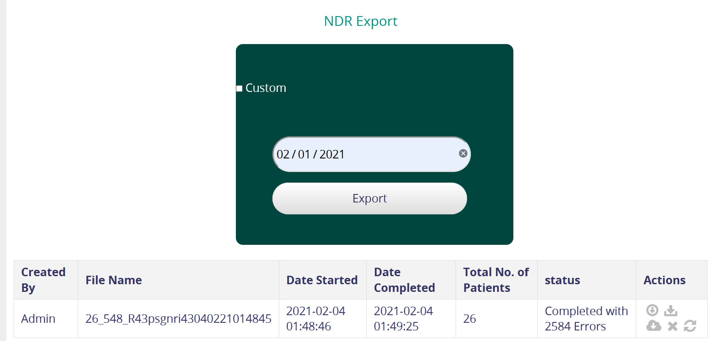

CONFIGURE THE REPORING MODULE JSON

After installation you will notice that key reports are still not showing up under the reporting module in the front end. To make reports show up in the front end, paste the text inside the NMRSReportConfig.json into the App Definition of NMRSreportingui.reports.

Click on “System Administration”

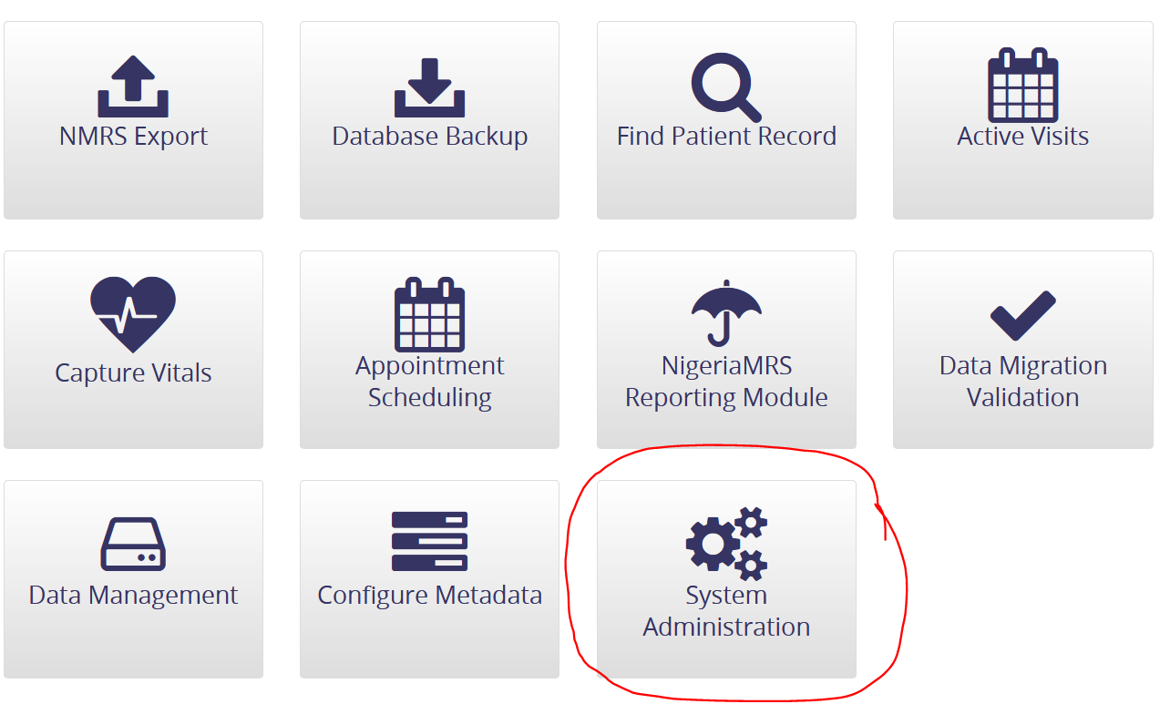

Click on “Manage Apps”

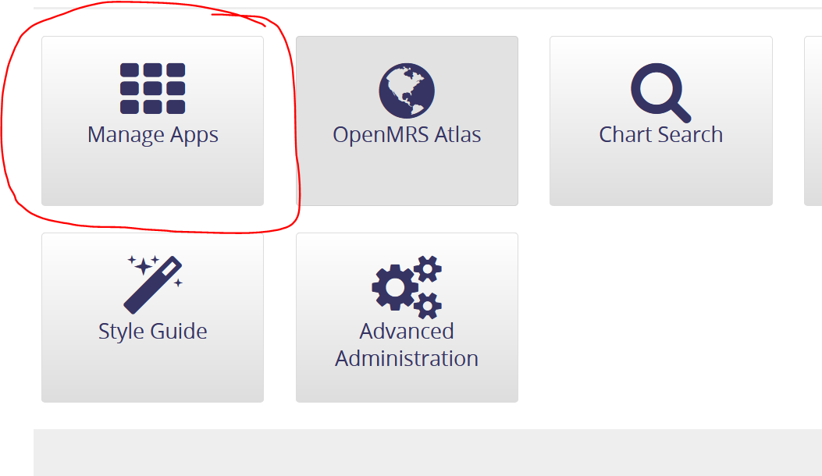

Locate the App config for “NMRSreportingui.reports”

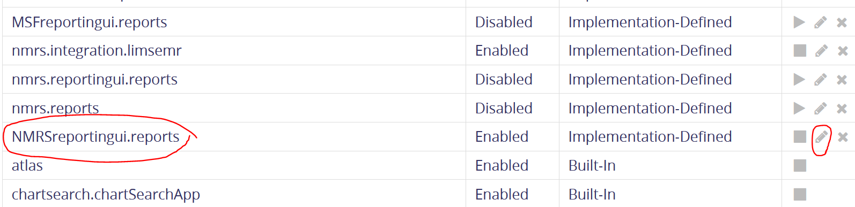

Paste JSON into this location

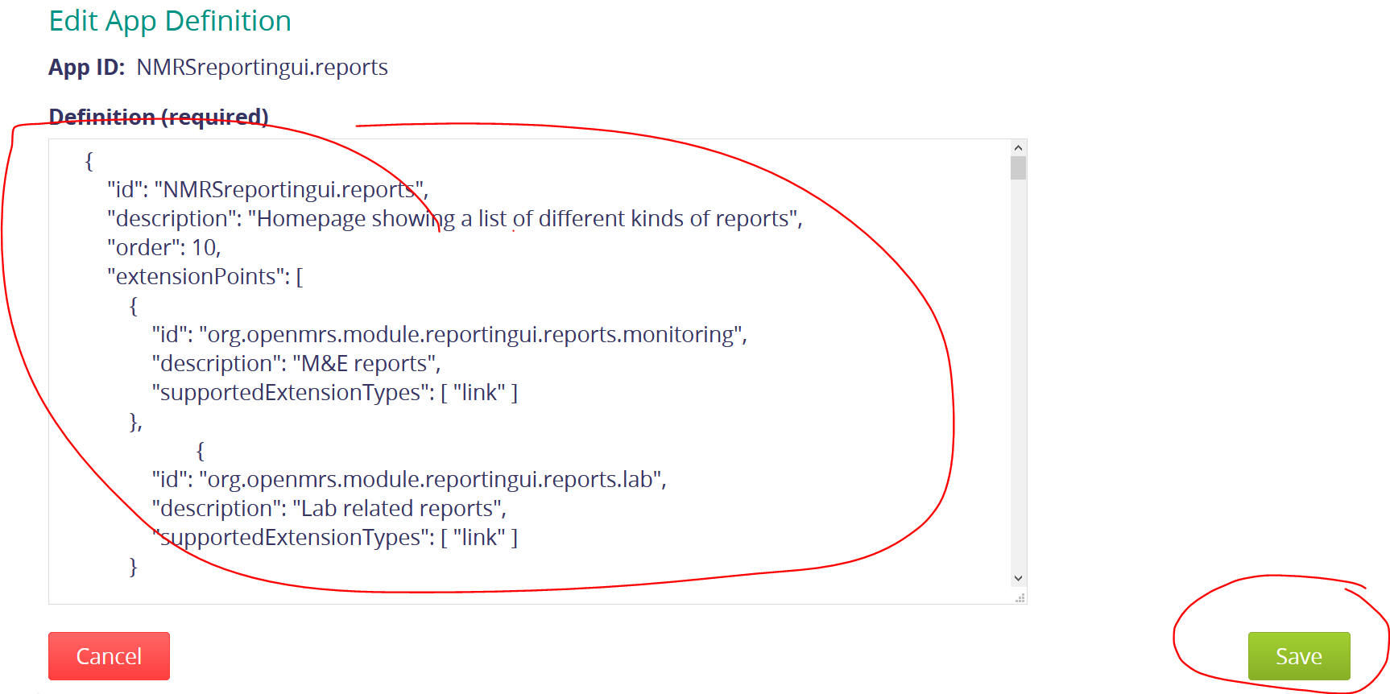

FIXING PREVIOUS ADD PAST VISIT ISSUES

The previous versions of PMTCT forms resulted submitted with data entry dates rather than visit dates. This can be resolved by running the add past visit scripts.

<https://github.com/ihvn2020/appconfig/blob/main/CHANGE%20DATA%20ENTRY%20DATES%20TO%20VISIT%20DATES.sql>

References

NMRS Metadata Tables

1. concept* (All tables beginning with concept);
2. encounter_type;
3. form;
4. field;
5. field_answer;
6. field_type;
7. form_fields;
8. form_resources;
9. htmlformentry_html_form;
10. patient_identifier_type;
11. program;
12. relationship_type;
13. report* (all tables begining with report);
14. serialized_object;
15. appframework_component_state;
16. appframework_user_app;

NMRS DATA TABLE

1. patient;
2. patient_identifier;
3. patient_program;
4. person;
5. person_name;
6. person_address;
7. person_attribute;
8. encounter;
9. encounter_provider;
10. visit;
11. obs;
12. relationship;
13. biometricinfo;
14. users;
15. user_role;
16. role;
17. role_privilege;
18. privilege;
19. role_role;
20. provider;
21. location;